**GOVERNMENT COLLEGE OF ENGINEERING [IRTT]**

**ERODE - 638316**



**ELECTRICAL AND ELECTRONICS ENGINEERING**

**NAAN MUDHALVAN**

**DIGITAL MARKETING**

**ASSIGNMENT**

NAME: NIRMAL KUMAR S

NM ID: 2838470FD54BEFABEAF4CE5B027B5AA1

BRAND NAME: Memorial trust

USER NAME: au731120105020

**1.Create a blog or website using BlogSpot and Customize the theme design and post new article with 500 words.**

**LINK: https://nirmalthangam.blogspot.com/2023/09/thangam-memorial-trust-animal-welfare.html?m=1**

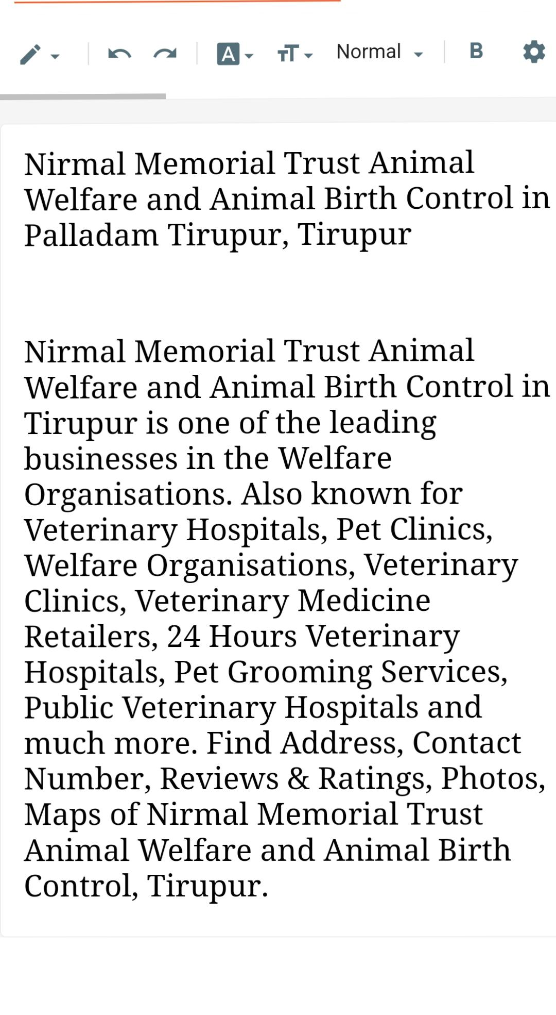**SCREENSHOTS:**

**2 Create a New Facebook Business Page and post one social media poster for your brand.**

**LINK:** https://www.facebook.com/profile.php?id=61550574113585&mibextid=ZbWKwL

**SCREENSHOT:**

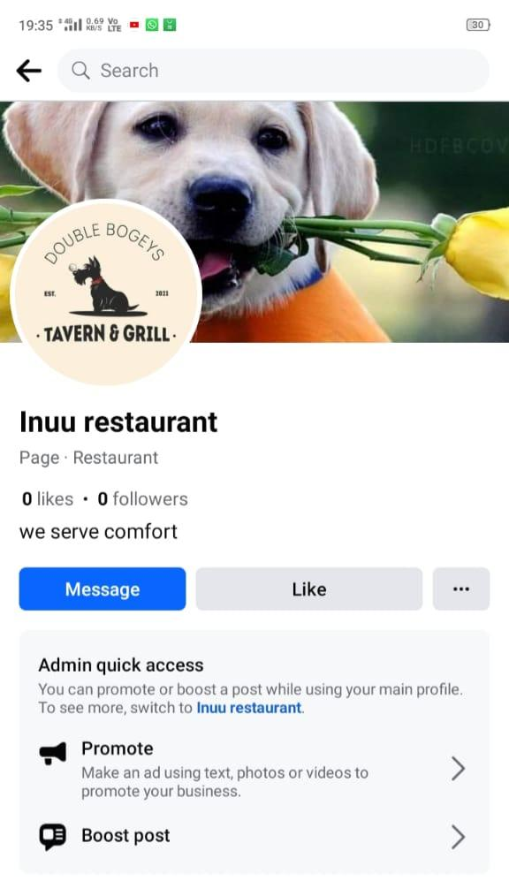

**3.Create and design a social media advertisement poster using Canva.**

**LINK : https://www.canva.com/design/DAFtAFpn9bc/WozVMa0DSNW11HtTkW2iFA/edit?utm_content=DAFtAFpn9bc&utm_campaign=designshare&utm_medium=link2&utm_source=sharebutton**

**SCREENSHOTS:**

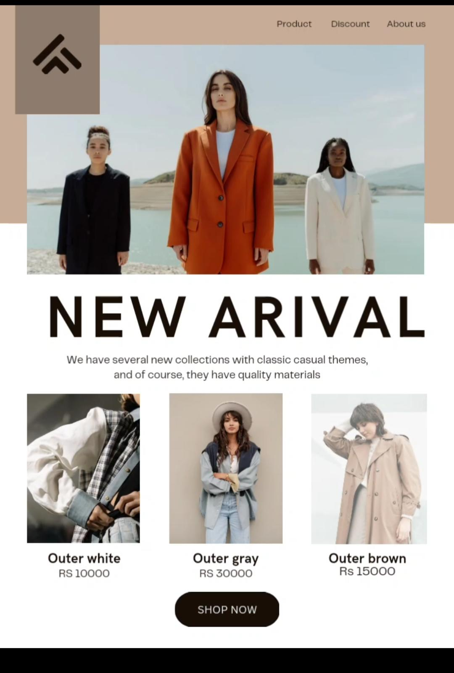

**4 Create Email Newsletter design using Canva tool.**

**LINK:** **https://www.canva.com/design/DAFtAFpn9bc/WozVMa0DSNW11HtTkW2iFA/edit?utm_content=DAFtAFpn9bc&utm_campaign=designshare&utm_medium=link2&utm_source=sharebutton**

**SCREENSHOTS:**

